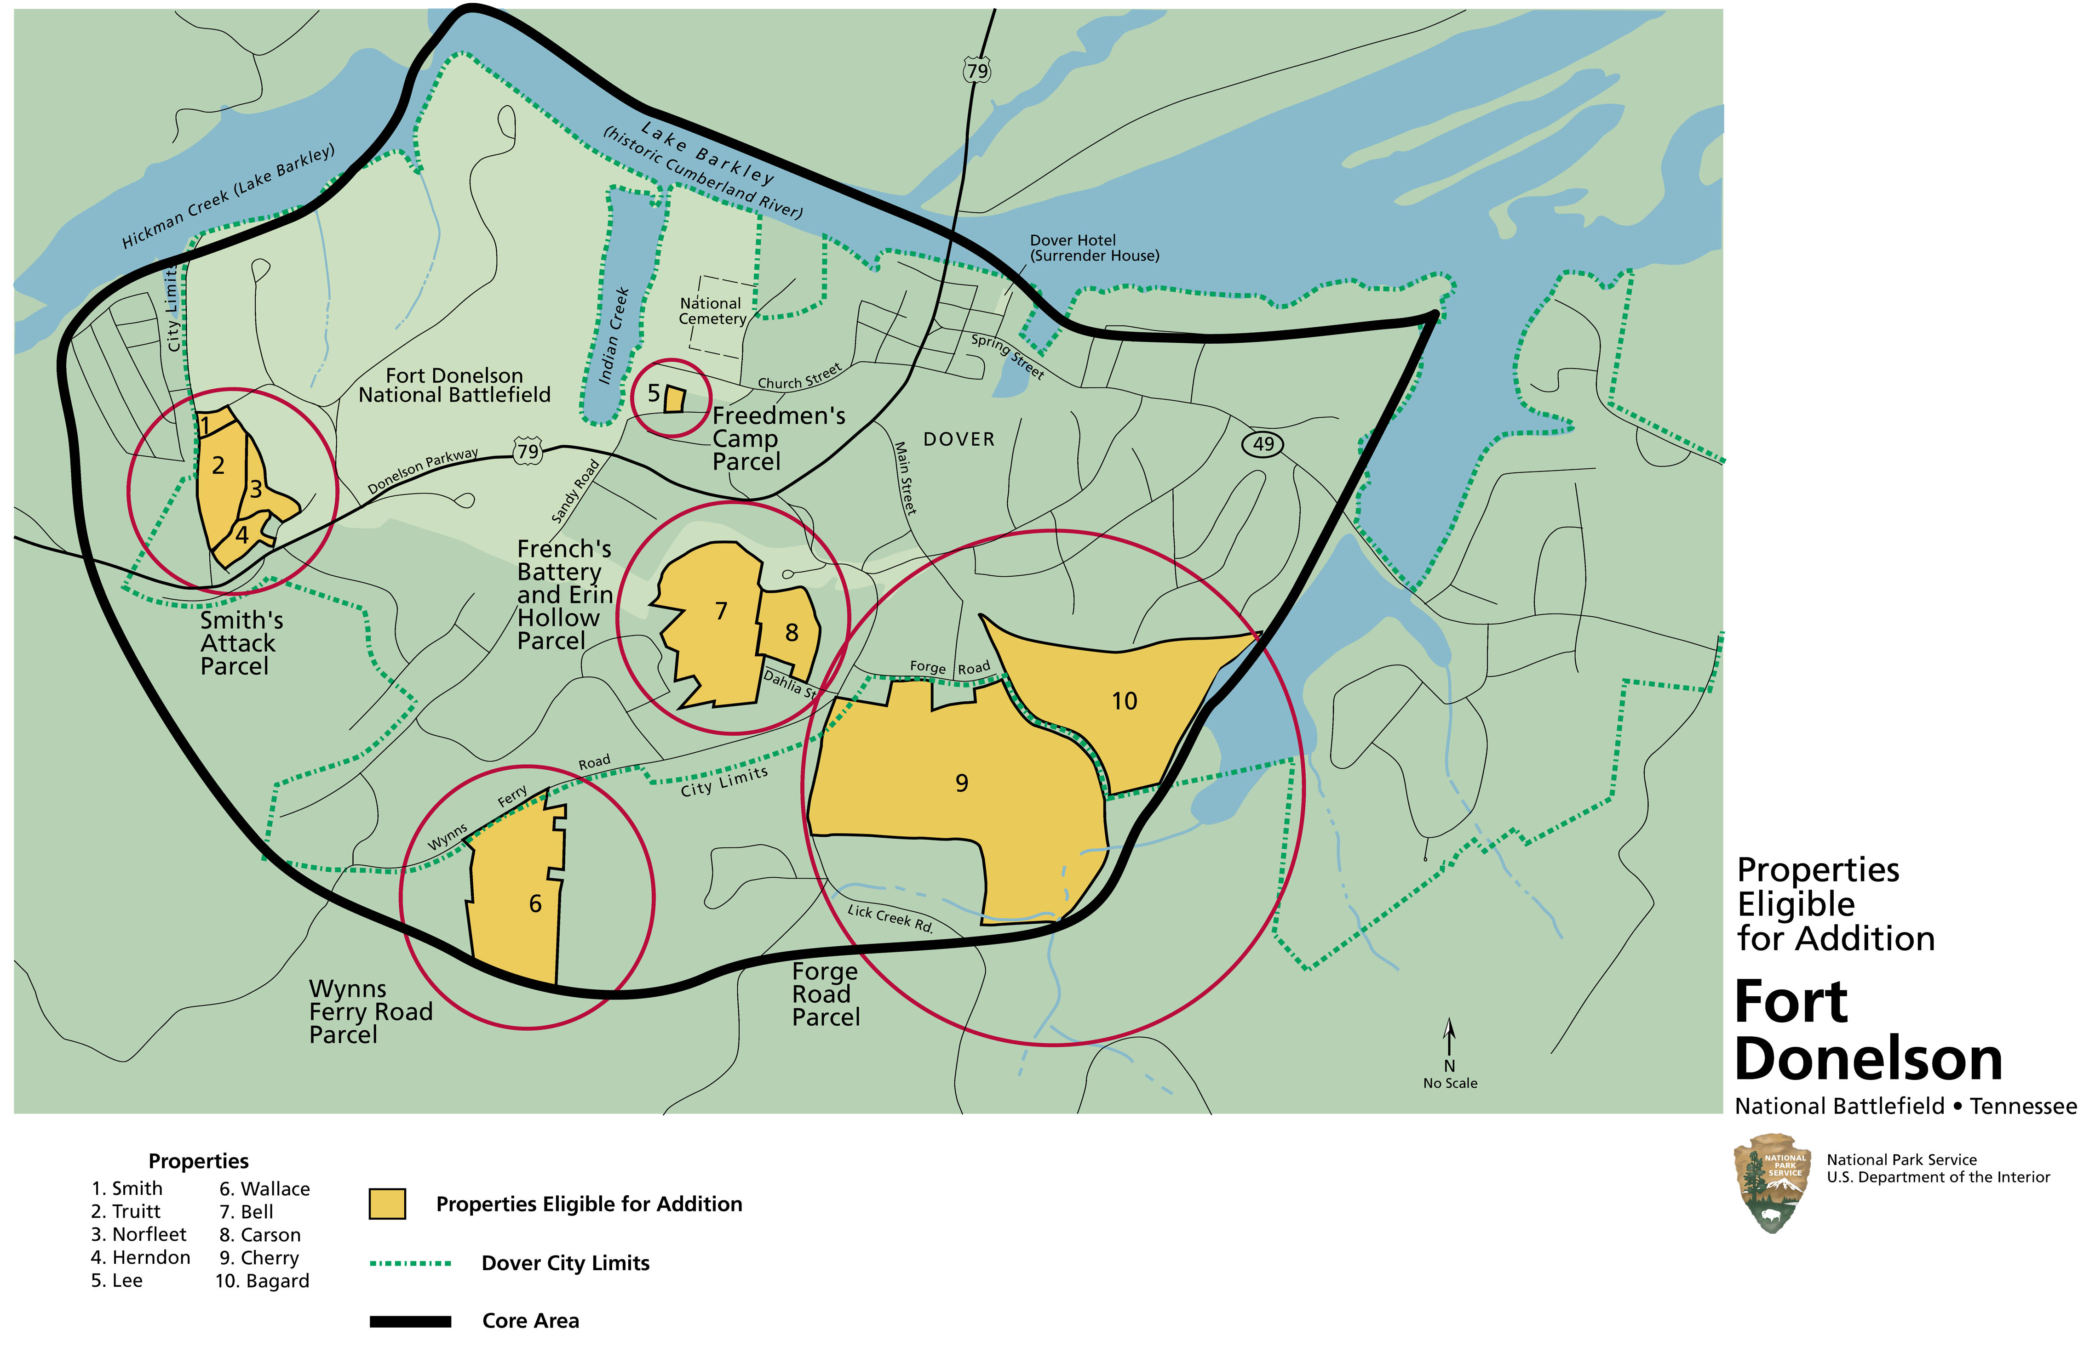

Figure 1-21. Properties eligible for addition to Fort Donelson National Battlefield

